CURRICULUM VITAE 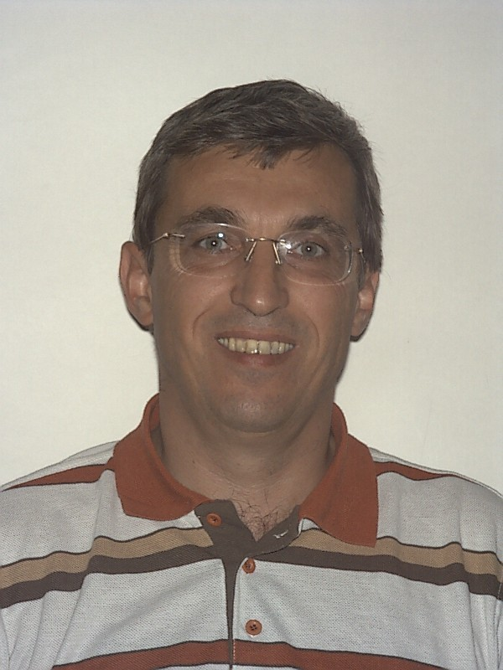
PERSONAL DATA
Surname Name : A n d r ý s e k O l d ř i c h
Address (office) : c/o UNHCR DIPS, 94, Rue de Montbrillant
1202 Geneva, Switzerland
mob: 0041-79-2354680; email: oldrich.andrysek@gmail.com
Date/Place of Birth : 3 January 1960, Czechoslovakia
Marital status : separated (son *1985; daughter *1994)
Nationality : Czech/Dutch (naturalized)

EDUCATION

1980 - 1985 Faculty of Law, Charles University, Prague; specialization in public international law (diploma thesis on Jus Cogens);
1987 - 1988 computer programming and data management;

EMPLOYMENT

January 2011 Regional Represenative for Ukraine, Belarus and Moldova (Kiev Ukraine)
2006-2010 Chief, Policy and Legal Advice, DIPS, UNHCR Geneva
2002 - 2006 Chief, Protection Information Section, DIPS, UNHCR Geneva
1998 - 2002 Representative, UNHCR Moldova
1996 - 1998 Senior Refugee Officer, IFRC Geneva (Special leave without pay from UNHCR)
1994 - 1996 Deputy Regional Representative, UNHCR Regional Office Vienna;
1991 - 1994 Head of Desk, UNHCR, Regional Bureau for Europe, Geneva;
1990 - 1991 Associate Human Rights Officer, UN Centre for Human Rights, Geneva;
1987 - 1990 Senior Legal Researcher, International Humanist and Ethical Union, Utrecht;
1986 - 1987 Researcher, Netherlands Institute for Human Rights - SIM, Utrecht.

RELEVANT EXPERIENCE

UNHCR HQs: Chief of Sections responsible for protection policy and legal advice (prior to that responsible for data/country of origin information/knowledge management); Inspector General’s Office, Regional Office Kiev responsible for EU funded project, Special Advisor to the AHC for Protection). UNHCR Moldova: Head Branch Office (seven staff and 615.000 USD in programmes.) In IFRC: responsible for policy and legal advice on human rights and refugee law issues. UNHCR Regional Office in Austria: coordination of legal projects in Central Europe, liaison with representatives of government, non-government and international organizations (e.g. OSCE Secretariat, HCNM and ODIHR, Council of Europe). UNHCR Hqs, Head of Desk: covered Albania, Austria, Bulgaria, Czechoslovakia, Hungary Poland, Romania and the former USSR and oversaw the establishment of a UNHCR field presence. UN Centre for Human Rights: secretarial support to Treaty based human right bodies receiving individual complaints. Prior to UN career: worked for Radio Prague, as a freelance translator, Dutch NGOs, completed a fellowship of the Council of Europe Directorate of Human Rights and attended Study Sessions of the Strasbourg International Institute of Human Rights. Lectured on refugee, humanitarian and human rights law, minority rights, individual complaints procedures and religious intolerance (e.g. Centre for Human Rights, Geneva; Hanns Seidel Stiftung; University of Santa Clara Summer Courses, the Graduate Institute of International Studies, Institute Henri Dunant, Geneva; De Paul University, Chicago; AEGEE Freiburg and Budapest; Diplomatische Akademie Wien; University of Lund (RWI); Faculty of Law Belgrade; Ministry of Interior Beijing (China), Moldova State University, Central European Academy of Science and Art Timisoara). Computer literate (Word, Excel, Basic, SQL Oracle etc.).

SPECIFIC INTEGRATION RELATED EXPERIENCE
As part of my UNHCR/Red Cross work I have designed/drafted local integration projects and monitored their implementation. As appropriate in the local context such projects included income generation, job placement/counselling, language courses etc.. Negotiated with Government administrations and lawmakers the adoption of national legislation in a number of jurisdictions (including implications for labour, residency, documentation, naturalisation laws/regulations etc.).

SELECTED PUBLICATIONS
- Report on the Definition on Minorities, SIM Special No. 8, 1989;
- The position of non-believers in nat. & intern. law with special refer. to the ECHR, 1989;
- Translation into Czech of the European Convention for Human Rights and Fundamental Freedoms, Social Charter and the Penitentiary Rules (for the Council of Europe);
- Non-believers: A New Aspect of Religious Intolerance? Conscience and Liberty, 2/1990;
- The Policies of UNHCR in Central and Eastern Europe, Helsinki Monitor, Vol. 4/1, 1993;
- Group and Collective Rights, Prava I Slobode, Belgrade Centre for Human Rights, 1995;
- Individual Complaints Procedures under UN Instruments, Affirmative Action Implications - Positive Experiences (UNHCR Bratislava, 1996);
- Gaps in International Protection and the Potential for Redress Through Individual complaints Procedures (IJRL, Vol. 9, 1997);
- The Intern. System Protecting Refugees and Persons in Ref. Like Situations and the Role of UNHCR, Drepturile Omului in Republica Moldova, Chisinau 1998 (Rom.), 1999 (English);
- Torture and Trafficking in Persons, Encyclopedia of Public International Law, Max Plank Institute, Vol. IV (Q-Z) 2000;
- The Link between the 1951 Convention and the ECHR – a Complimentary Instrument for the Protection of refugees and Asylum Seekers, European Convention on Human Rights and Protection of Persons in need of International Protection (Chisinau 2000)
- Protecting Refugees and Persons in Refugee Like Situations at the turn of the Millenium, Festschrift, (in INTERNATIONAL HUMAN RIGHTS MONITORING MECHANISMS, pp. 343-355, 2001, Kluwer Law International);
- Unworthy Partner: the schools issue as an example of human rights abuses in Transdniestria, (Helsinki Monitor, Vol.14/ 2, pp. 101-116, 2003, Kluwer Law International)

LANGUAGES
- mother tongue Czech; fluent: English, Russian and Dutch;
- working knowledge: French, German, Slavic languages.

Kyiv, 27 June 2011

